SPRINGFIELD HOUSE MEDICAL CENTRE
275 Huddersfield Road,
Oldham OL4 2RJ
Tele: 0161 667 2480
Email: OLDCCG.SpringfieldHouse@nhs.net

www.springfieldhousemedicalcentre.nhs.uk

Opening Times

Monday: 08:00 – 18:30
Tuesday: 08:00 – 18:30
Wednesday: 08:00 – 18:30
Thursday: 08:00 – 18:30
Friday: 08:00 – 18:30

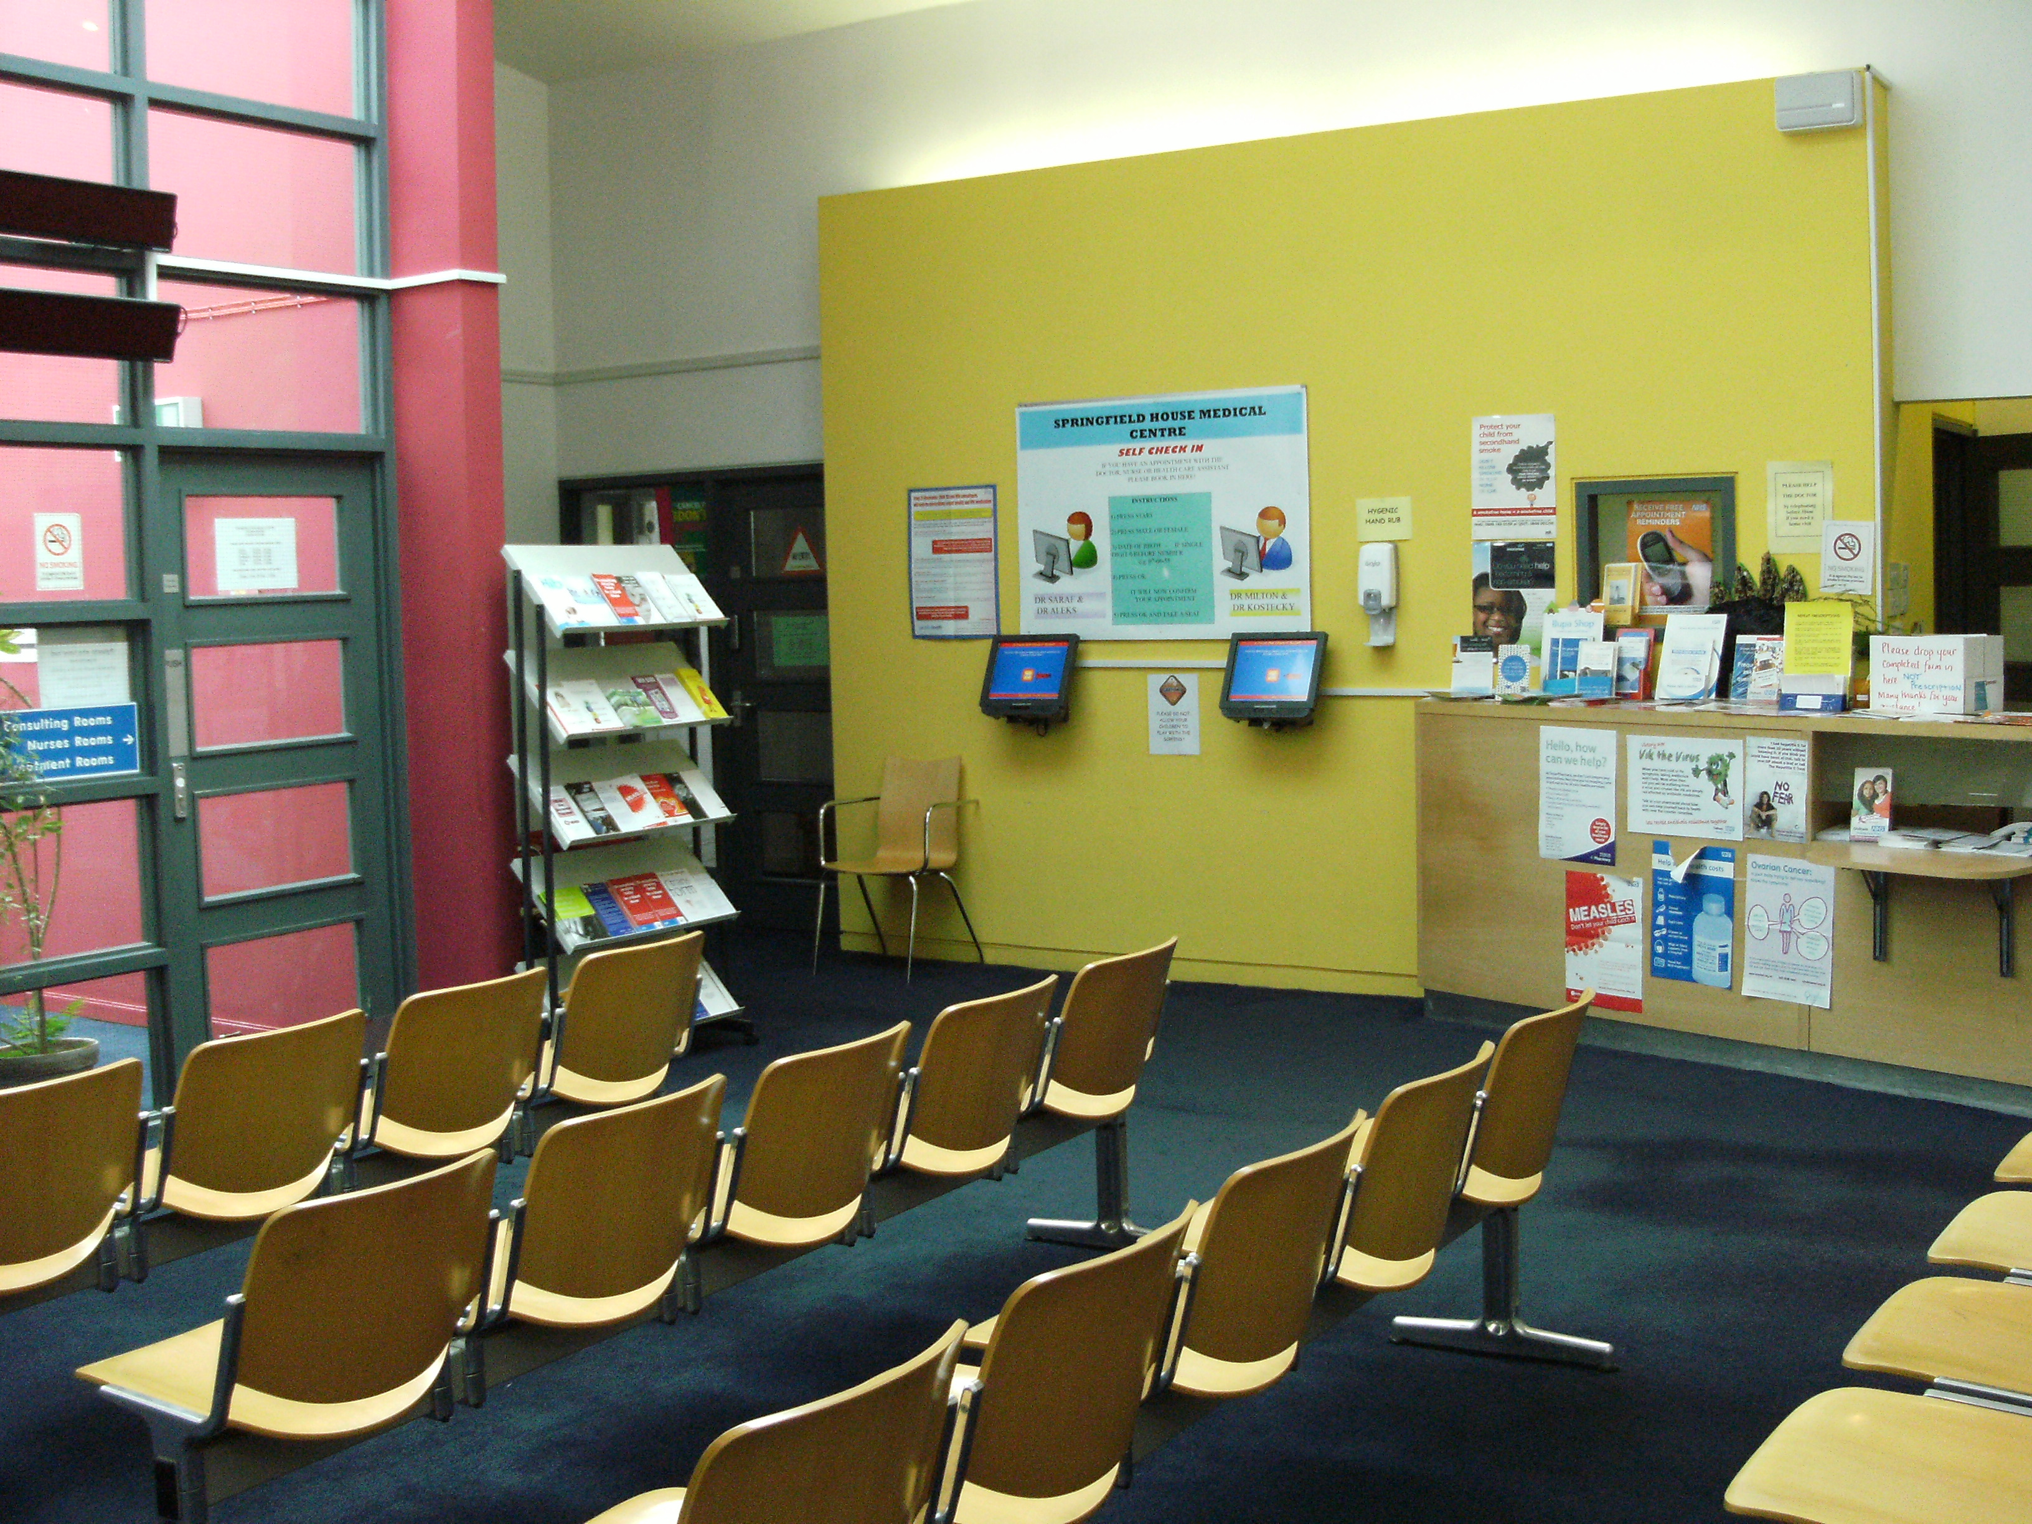

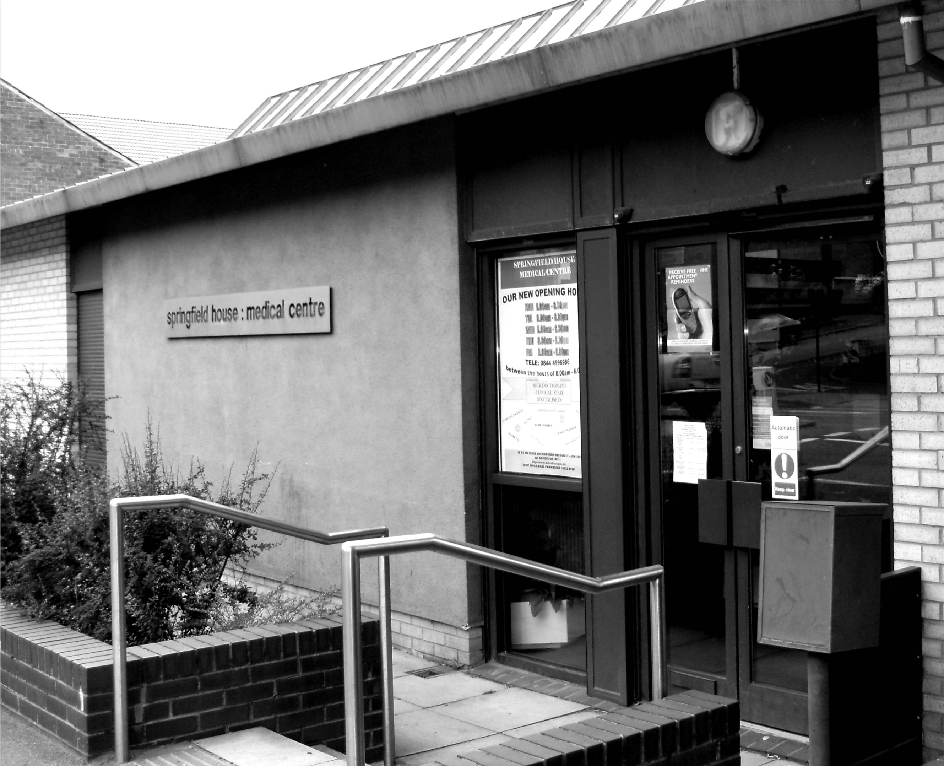

Doctor Saroj Saraf. MB DRCOG, DFFP (Female)
Doctor Aleksandra Makojnik. MRCGP, DFSRH, Lekarz (Female)
Doctor Daniel Coates MB ChB (Male)
Doctor Benjamin Gibson MB ChB (Male)
Doctor Joe Anne Ong MB ChB (Female)

Mission Statement
“The Practice is here to give our patients high quality care.
Whilst you are visiting our premises you have the right to expect courtesy
and consideration from our staff, our patients and visitors.”

WELCOME TO
SPRINGFIELD HOUSE MEDICAL CENTRE.

Springfield House opened originally in 1968 as one of the first purpose-built surgeries in Oldham. It was designed and built by two local practices in order to provide modern premises to serve their patients.

Over the years as the provision of healthcare changed and more services were offered to patients, the premises became inadequate and modernisation was needed.

In 1998 a new section was added to the original premises and the old section was extensively refurbished to provide the modern surgery you see today.

Surgery Times

 | Monday | Tuesday | Wednesday | Thursday | Friday
Dr S.  Saraf | 09:00 – 10:00  On Call | 08:30 – 11:00  14:30 – 17:00 | 08:00 – 11:00  15:00 – 16:00 | - | -
Dr A Makojnik | 08:30 – 10:30  15:00 – 17:00 Tutorial - | - | - | 09:00 – 10:00  On Call | 08:00 – 10:30  13:30 – 16:00 Sexual Health
Dr D. Coates | - | - | 09:00 -10:00  On Call | 08:30 – 11:00  14:00 – 16:30 | 08:30 – 11:00  14:00 – 16:30
Dr B. N Gibson | 08:00 – 10:30  13:30 – 16:00 | 09:00 – 10:00  On Call | 09:00  Tutorial  15:00 – 17:00 | - | -
Dr J Ong | - | 09:00 – 11:30  15:00 – 17:30 | - | 09:00 – 11:30 | 08:30 – 10:00  On call

Bank Holidays

Please note we are closed on bank holidays.

The Practice Team

Our staff are highly experienced and are there to help you.

Practice Nurses.

Joanne, RN
Sharon, RN

Clinical Support

Jeanette – Assistant Practitioner.

Administration

Lindsey – Practice Manager
Susan - Office Manager.

Reception

Joan Lisa Kirstie
Linda Saskia Kath
Melanie Sarah

Nicola – Secretary/Admin
Rachel - Secretary/Admin
Natalie – Secretary/Admin

Appointments

- We operate a same day booking system as well as pre-bookable appointments. You can book up to 6 weeks in advance to see any of the Doctors.
- Appointments can be made by telephone, online or by calling into the surgery. Urgent problems can be seen the same day and emergencies dealt with as soon as possible.
- You can also book your own appointments, order your repeat prescriptions, get access to your medical records and inform us of any changes to your home address or telephone number, via our Clinical system.
- Please be punctual and if your appointment is no longer required please remember to cancel it. If all the appointments have been booked you will be directed to the Walk-In-Centre, in the Integrated Care Centre, opposite the Bus Station, where appointments are not necessary.
- Please take time to look at our DNA policy which is available on our website.
- We offer same day appointments for children under the age of 5 years if clinically urgent
- Please note that the Drs will only deal with one problem per appointment.

Evening and Weekend - 7 day service

GP appointments are now available at selected location in Oldham from:
•6.30pm - 8pm Monday to Friday
•10am - 2pm Saturday and Sunday
Anyone registered with an Oldham GP is able to choose from appointments available across the borough. This is not a walk-in service. These non-urgent and routine appointments must be booked in advance and may not be with your own GP. Call 0161 934 2827 to book an appointment

Staff Training

We close one afternoon a month for staff training. Please see our website for dates each month.

Repeat Prescriptions

Please use the counterfoil on your prescription to request a repeat. Hand this in at reception or place it in the box in the foyer. Please allow 48 hours the prescription to be processed. Alternatively you may send the request by post. If you would like the prescription to be sent back to you by post please send a stamped addressed envelope.
You can also order online – please ask at Reception to register with Patient Access or via email to oldccg.springfieldhouse@nhs.net

Please note, we do not take repeat requests over the phone.

Test Results.

Results will only be given to the patient in person. Please telephone or call into Reception

CLINICS
Carers Health Checks

Please inform the surgery if you are a carer as you are eligible for a health check.

NHS Health Checks

If you are aged between 40 – 74 then please ask at reception if you are eligible for a free NHS health Check.

Family Planning

The Practice provides a full range of family planning and treatment during normal surgery times.

Child Health Surveillance

The Practice offers full developmental assessment and immunisation programmes.

Minor Surgery

Run by Dr. Saraf, for the treatment/removal of warts, skin tags etc.

COPD Clinic

Run by Joanne and Sharon by appointment.

Diabetic Clinic

Run by Joanne and Sharon by appointment.

Other Clinics -Hypertension, Asthma, Healthy Heart etc

We can offer you an appointment with one of our Nursing staff. Please ask at Reception.

Vaccination for Foreign Travel

Both of our Practice Nurses are qualified and experienced to advise you of your requirements for travel vaccination. Please allow at least six weeks before travel to organise and complete your vaccination course.

Flu Vaccination

This is advised for patients with heart, lung, kidney disease or diabetes, for residents of nursing and retirement homes, for people over the age of 65 and Carers. Please contact the surgery during September for details of vaccination clinics.

Chaperones

All patients are entitled to have a chaperone present for any consultation. Please request this at the time of booking or speak to your GP

Home Visits

All home visit requests are triaged by the on call GP. All doctors are happy to visit patients at home when necessary. Please try to come to surgery if at all possible as you may be dealt with more quickly and the examination facilities are better at the Practice premises. If you do need a home visit please try to request it before 10.00am and give the receptionist as much information as possible so that visits can be prioritised in order of urgency.

You and your doctor

Patients are now registered with a “named” GP (dependant on your surname), for administrative reasons your medical card will be issued in the name of one doctor, however you can at any time express a preference for a particular doctor, for either all of your medical needs or on a care-by-case basis. However, not all the doctors in the Practice provide all services and specific doctors may not be immediately available.

If you have not been seen at the surgery for three years (or one year for those over the age of 65) you can request a check up appointment if you wish.

Health Advice

If you are unsure about whether you need to see a doctor or have a health query, you can call NHS 111 or speak to your local Pharmacist.

Out of Hours Calls.

If you require Urgent Medical Assistance between the hours of 18:30 and 8:00, when the Surgery is closed, you need to dial 111 directly.

Calls to the NHS 111 Service are free from both landlines and mobiles.

New Patients

We are happy to welcome new patients to the Practice who are in our Practice boundary. All new patients will be offered an appointment for a health check if necessary/required. It is the patient’s responsibility to notify the surgery when an appointment made previously needs to be cancelled. Patients can choose which GP they wish to see.

Computerisation

Our Practice is fully computerised, maintaining accurate medical records and registered under the Date Protection Act and GDPR regulations. Please help us by advising as soon as possible of changes of name, address and telephone number.

Data Protection and GDPR

All information held about patients is completely confidential. The Practice is registered under the Data Protection Act 1984. This Act protects data held on the computer system. We are fully compliant with the new GDPR regulations that came in to force in May 2018. Please see our website for more information.

Right to Complain

We always try to give you the best service possible but there may be times when you feel this has not happened. If you have a complaint you must first bring it to the attention of one of our staff. If the matter cannot be resolved on the spot and you wish to take if further, please telephone or write to our Office Manager, Susan Hall who will deal with it in the best possible way.

Violence and Abuse

The Practice will not tolerate violence and verbal abuse towards any member of staff. Violent and abusive patients will be reported to the Police and removed from the Doctors List.

Comments and Suggestions

We would welcome any comments and suggestions regarding our services but please understand that comments are not complaints and will not be dealt with as one.

Disabled Access

Our premises have suitable access for disabled patients and all the patient areas, including waiting room, consulting rooms and toilets have wheelchair access. There is also a designated disabled parking bay right outside the surgery.

Walk In Centre

If you require treatment or advice with minor illnesses and injuries, such as infection and rashes, fractures and lacerations, emergency contraception and advice, stomach upsets, cuts and bruises or burns and strains you can attend the Walk In Centre in the Integrated Care Centre, on New Radcliffe Street in Oldham (opposite the bus station) without making an appointment. The Centre is open 8am – 8pm, 7 days a week.

Training Practice

As a teaching Practice, medical students spend part of their training with us from Manchester Medical School. We would value your co-operation with this, but we understand if you do not want to be involved.

Online Access

All patients will have online access given at registration

Practice Area.

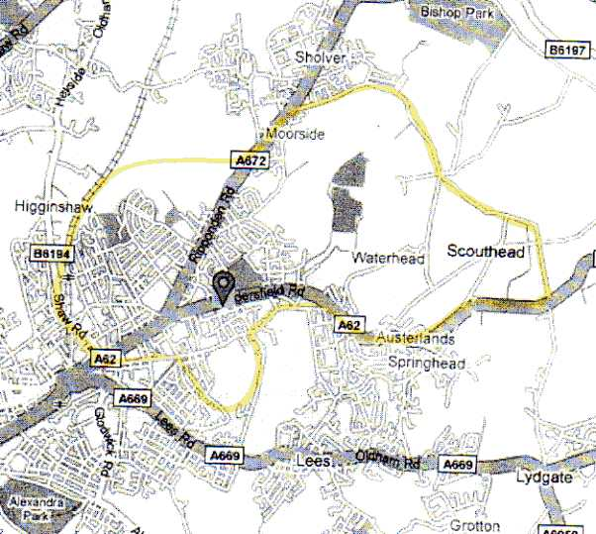

Primary Care Support Services (NHS).

Advice on other Primary Care Services can also be obtained from:

Primary Care Support Services
3 Caxton Road
Fulwood
Preston
PR2 9ZZ
Tel: 01772 221 326
Fax: 01772 221 447

USEFUL INFORMATION.

Clinical Commissioning Group (CCG)

The surgery is included in the Oldham CCG. The details are:-
Oldham CCG
Ellen House
Waddington Street
Westwood
Oldham
OL9 6EE
Tel: 0161 622 6500

Local Hospitals: Pennine Acute Hospitals.

The Pennine Acute Hospitals have a single switchboard number, 0161 624 0420 from which you can be put through to any of there hospitals or wards.

The addresses for the hospitals are:
- Fairfield General Hospital, Rochdale Old Road, Bury, Lancs. BL9 7TD
- Rochdale Infirmary, Whitehall Street, Rochdale, Lancs. OL12 ONB
- Birch Hill Hospital,. Rochdale, Lancs. OL12 9QB
- North Manchester General Hospital, Delaunays Road, Crumpsall, Manchester M8 5RB
- The Royal Oldham Hospital, Rochdale Road, Oldham. OL1 2JH

Tameside Hospital NHS Foundation Trust.

Telephone 0161 922 6000 (switchboard)
Tameside General Hospital, Fountain Street, Ashton U Lyne, Lancs. OL6 9RW

LOCAL PHARMACIES.

Well Pharmacy, 242 Huddersfield Road, Oldham. OL4 2RB Telephone 0161 624 5768
Moorside Pharmacy, 679 Ripponden Road, Oldham OL1 4JJ. Telephone 0161 620 1400
Lloyds Pharmacy, 282 Lees Road, Oldham OL4 1PA Telephone 0161 624 3529

USEFUL TELEPHONE NUMBERS.

NHS 111 | 111
Hospitals
Royal Oldham Hospital | 0161 624 0420
Rochdale Infirmary & Birch Hill | 01706 377 777
Manchester Royal Infirmary | 0161 276 1234
North Manchester General (Crumpsall) | 0161 795 4567
General Information
Oldham Clinical Commissioning Group | 0161 622 6500
PALS - Patient Advice & Liaison Service (24 Hours) | 0800 389 8679
FRANK (Confidential Advice on Drugs) | 0800 77 66 00
Stop Smoking - Advice & Support | 0800 3288534
Refuge - Domestic Violence (24 Hours) | 0808 808 9999
Sexual Assault Centre - St Mary’s Hospital | 0161 276 6515
Well Spring Pregnancy Crisis Centre – Royton | 0161 624 3563
Citizens Advice Bureau | 0161 624 4870
Oldham Bereavement Support | 0161 627 2902
Spring Meadows Children’s Centre | 0161 770 8800
Oldham Carers Centre | 0161 770 1188 (Option 1)  www.wired.me.uk/oldham-carers.asp
Hospices
Dr Kershaw’s – Royton | 0161 624 2727
Springhill – Rochdale | 01706 649920

MASH (Multi Agency Safeguarding Hub) 0161 770 1122

Andy’s Man Club #itsokaytotalk – www.andysmanclub.co.uk Please see leaflets/posters in the surgery for more information

